ESSAY WRITING TIP SHEET

Introductions and Conclusions:
- Start your introductory paragraph with a bold statement, question, anecdote, or metaphor. You will then go on to state your reasoning behind your opinion. State your three reasons in a logical sequence. While this section should be brief, it needs to tell the reader what they are going to read about in your essay. To finish your opening paragraph write a bold and provocative thesis statement.
- Start your closing paragraph by rewriting/rearranging a your thesis statement. You will then go on to restate your reasoning behind your opinion. Finish your conclusion paragraph with a bold statement. You want your readers to finish thinking, “Wow. I’m impressed.”
Evidence:

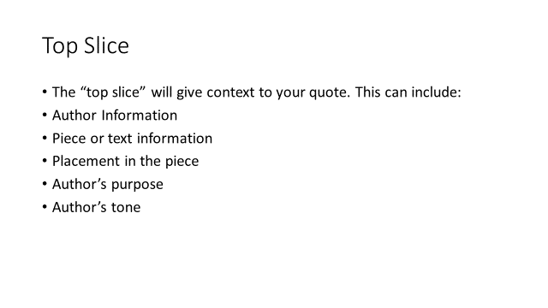
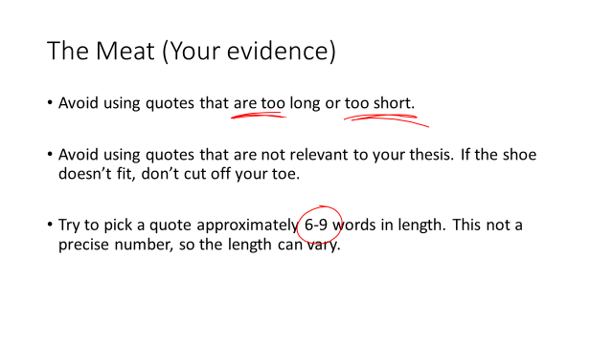

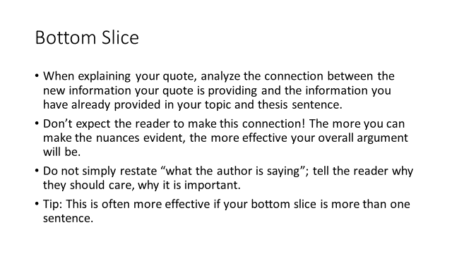
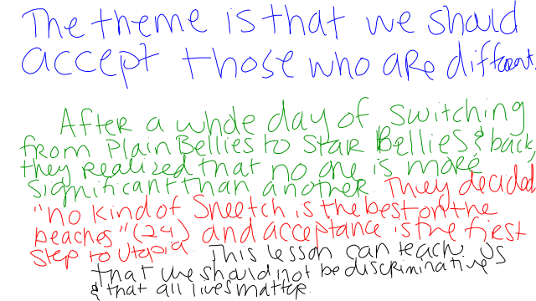

Style:
- In general, you should strive for direct, concise, and precise writing.
- Have you replaced “to be” verbs (be, been, is, are, were, was) with stronger, active verbs?
- Have you eliminated jargon, slang, clichés, and euphemisms in favor of more precise language?
- Have you eliminated repetition and redundancies? Read each sentence and ask yourself if it introduces a new information, ideas, or analysis. If it is simply restating old information, rewrite it or delete it
Dress Ups:
- -ly adverb (describe a verb)
- Who-which clause
- Strong verb
- Quality adjective
- because
- www.asia (when, while, where, as, since, if, although)
Ex: The angry fox bolted after the sneaky rabbit, who had stolen his carrots because he was famished.

